# NEWSLETTER HEADER 1.jpg

**PRESIDENT’S MESSAGE**

I begin my first report as president by acknowledging the contribution of the previous retiring Executive Committee members who have, over the past several years, worked tirelessly for the Association: Sharryn, Sandra and Kylie thank you on behalf of the members of ANNA. Sharryn is currently working as Webmaster as well as assisting me during my transition into the role of President. I certainly appreciate her willingness to continue her commitment after retiring as President after six years.

The preparations for our annual meeting are in full swing and we hope you will join us in Adelaide for the Conference “Building Bridges – Making Connections from 31 August -1 Sept 2017 at the Adelaide Convention Centre. We are once again collaborating with the Neurosurgical Society. Harriet Chan and Leigh Arrowsmith are co-convenors for the conference. It promises to provide everyone with a great mix of education and networking opportunities as well as the opportunity to take part in the social program on offer. Be sure and register before 1st July to take advantage of the reduced rate. If you are planning to present at the conference consider the scholarship opportunities available: the Barbara Lester Scholarship Fund and the Louie Blundell Scholarship. The details of both scholarships are available on the ANNA website and the closing date is the 31st May.

We are working to streamline our process for joining and renewing ANNA memberships. We would ask you to use your home email as your contact when renewing your membership. This ensures that communication from ANNA is getting to you. As we plan for new learning opportunities for our members it is important to make sure we have your most up to date contact. Our membership is stable but we certainly don’t take any of you for granted. Please let us know what we can do for you and also what you can do for us. If you have ideas that would help us to grow our membership base please share them with us. Sometimes just giving a colleague a nudge of encouragement to join ANNA is also beneficial.

Are you considering attending the WFNN Congress in Croatia? As an ANNA member you should be receiving the information about the Congress. I plan to attend and I will vouch for it being a great learning experience. It is such a pleasure to meet neuroscience nurses from other parts of the world and share in this educational opportunity with them.

Lastly on behalf of our journal editor, Linda Nichols, I would encourage you to submit a paper for publication in the journal. The details for submission are on our website and there is support out there for you if this is your first time writing for publication. While it can be daunting when complete it really does provide you with a great sense of accomplishment.

See you in Adelaide.

**Jeanne**

**ANNA President**

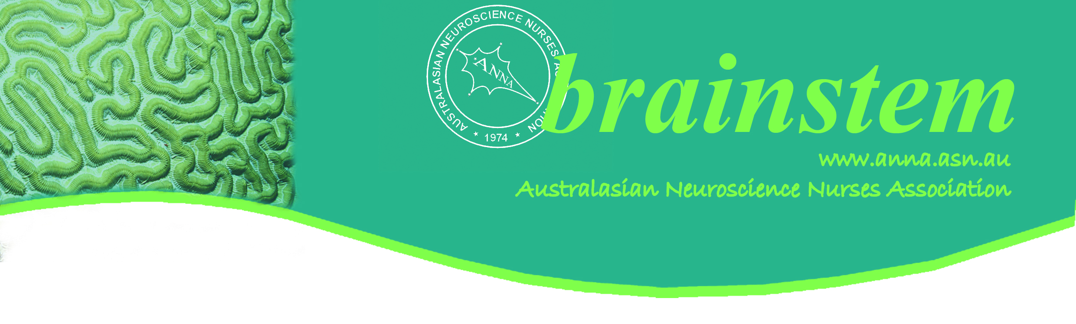

**ANNA CONTACTS**

|  |  |  |  |
| --- | --- | --- | --- |
| **ANNA** | PO Box 193 Surrey Hills Vic 3127 Email: [anna@pams.org.au](mailto:anna@pams.org.au)  Phone: 03 9895 4461 Fax: 03 9898 0249 | | |
| For specific executive inquiries, please contact the relevant committee member | | | |
| President | | Jeanne Barr | [president@anna.asn.au](mailto:president@anna.asn.au) |
| Vice President | | Debbie Wilkinson | [vicepresident@anna.asn.au](mailto:vicepresident@anna.asn.au) |
| Treasurer | | Catherine Hardman | [treasurer@anna.asn.au](mailto:treasurer@anna.asn.au) |
| Secretary | | Kate Lin | [secretary@anna.asn.au](mailto:secretary@anna.asn.au) |
| Webmaster | | Sharryn Byers | [webmaster@anna.asn.au](mailto:webmaster@anna.asn.au) |
| Conference Convenor | | Leigh Arrowsmith | [conferenceconvenor@anna.asn.au](mailto:conferenceconvenor@anna.asn.au) |
| Journal Editor | | Linda Nichols | [editor@anna.asn.au](mailto:editor@anna.asn.au) |

**Annual Australasian Neuroscience Nurses Day Competition**

**Winner post (Congratulation!)**

“Ward 7DNeurosurgery with Ward 7F Neurology

Royal North Shore Hospital

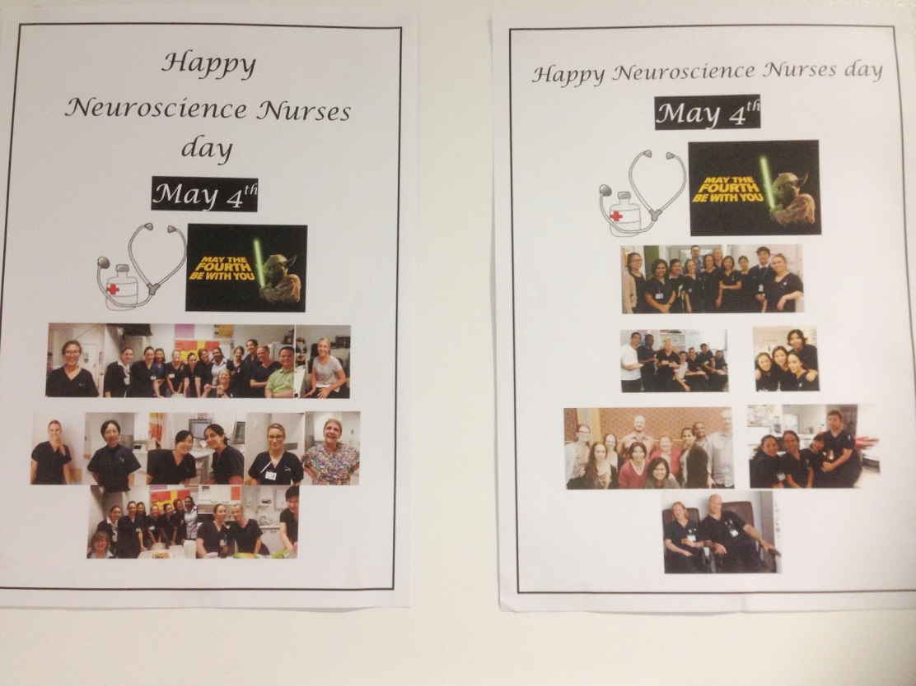

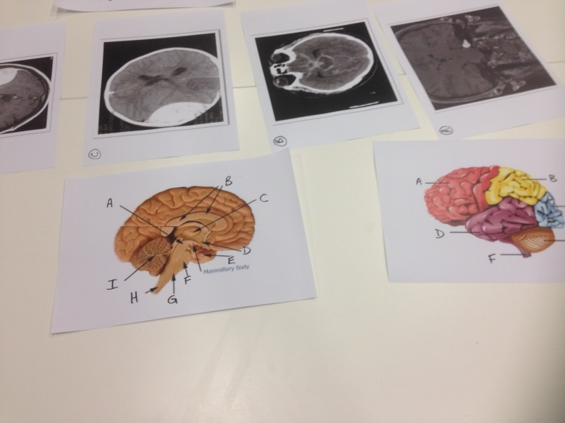 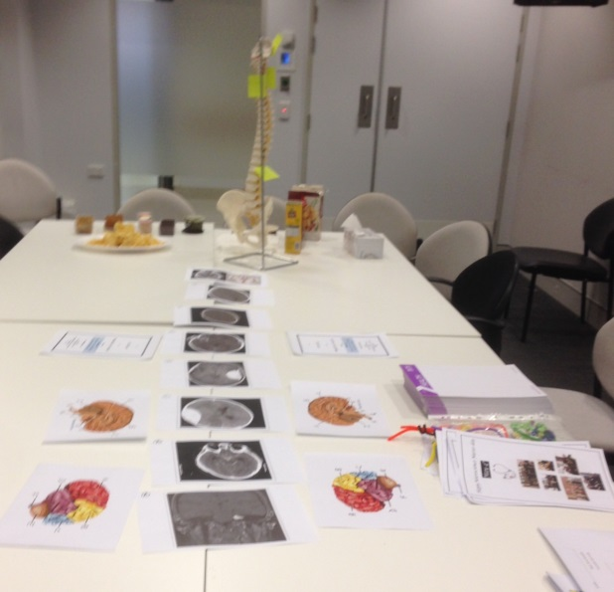

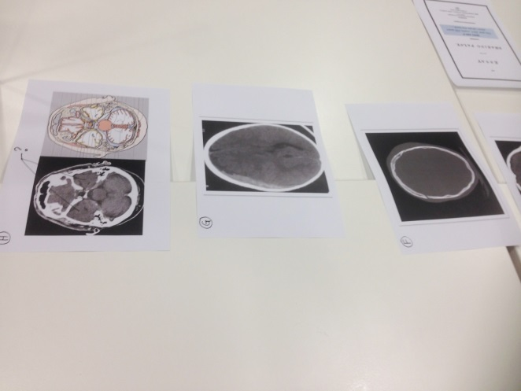 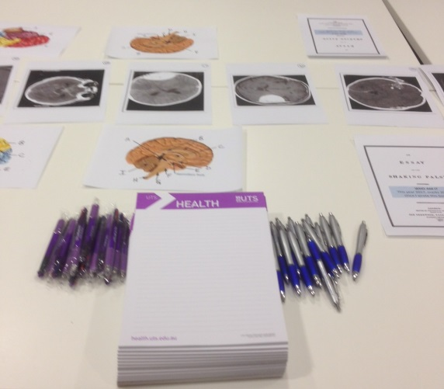

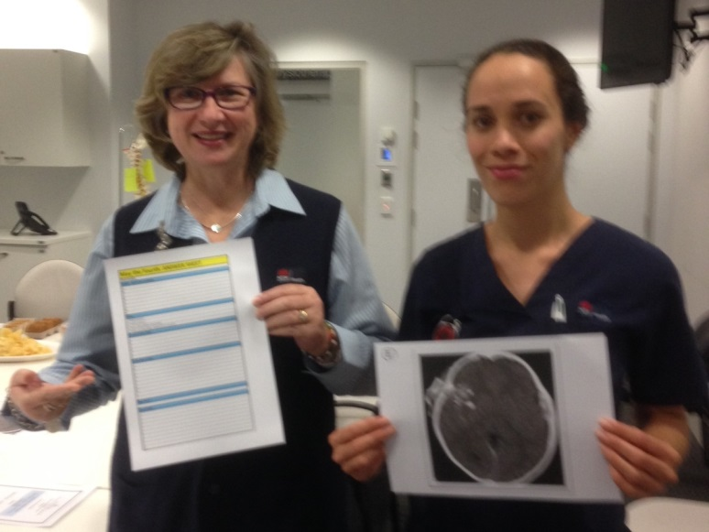 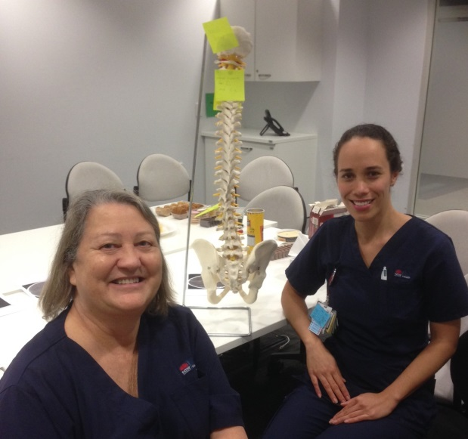

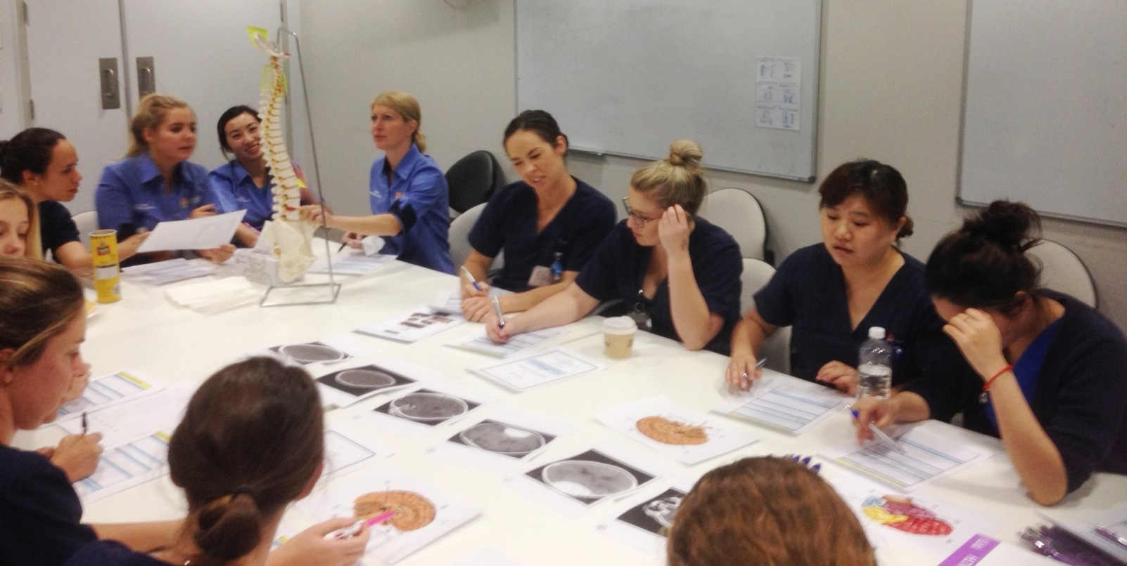

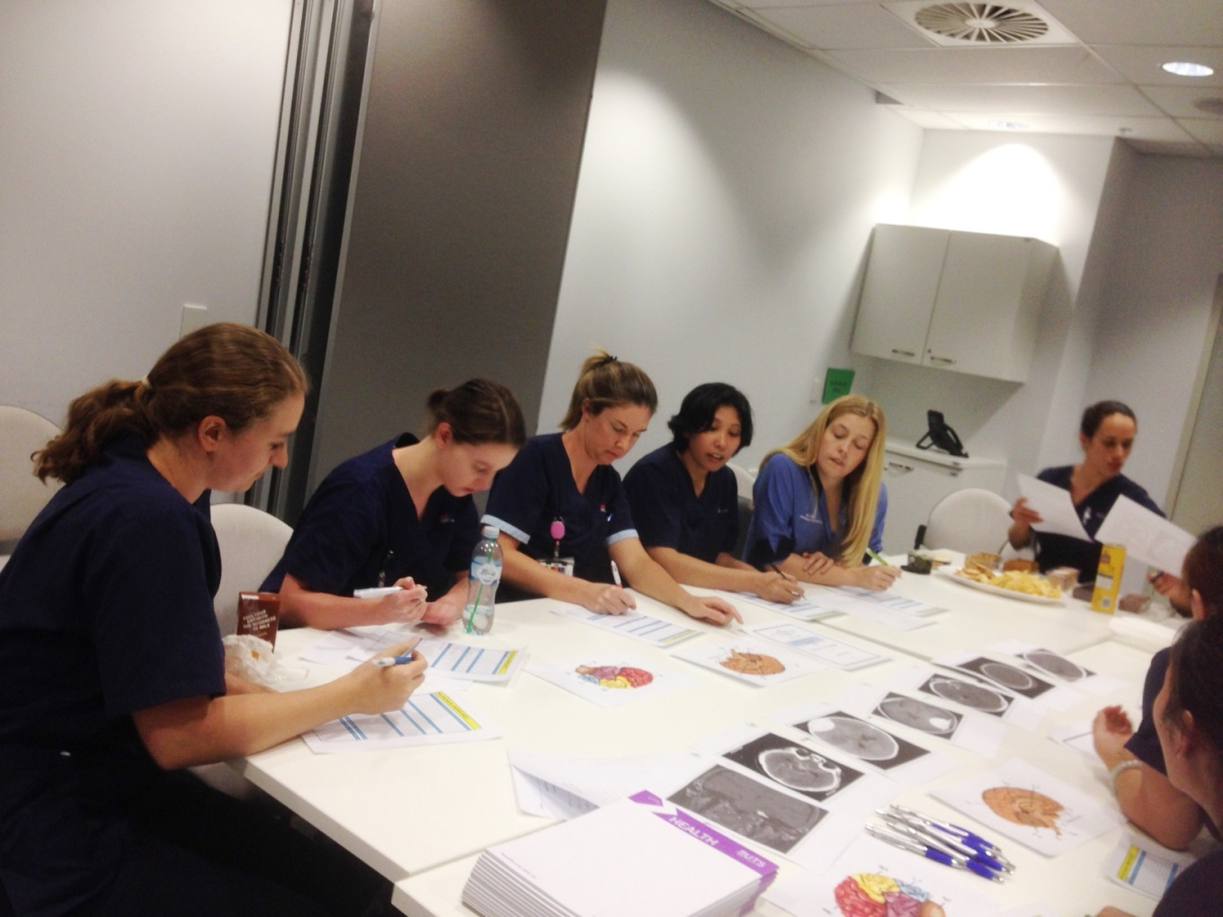

On Neuroscience Nurses Day 4th May 2017 we held a joint quiz session with staff from both Neurosurgery and Neurology. Afternoon tea was provided, with free pens and notepads as well as prizes. The staff had to identify conditions in CT scans, label the brain parts on two diagrams, identify structures on the spine model, name the famous person who wrote The Shaking Palsy, and unscramble some common neurological terms.

It was great fun and a decision was made to hold these joint sessions more frequent.”

Australasian Neuroscience Nurses’ Association

Annual Conference 2017

Care and Collaboration

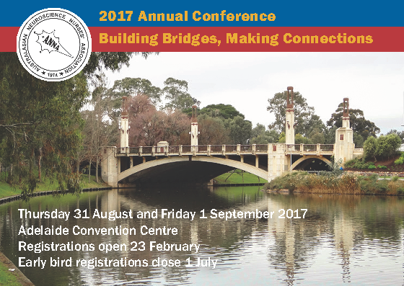

For sponsorship, exhibition and attendance information, please contact:

Website: [www.neuroasm.com.au](http://www.neuroasm.com.au)

Email: [nsa.asm@surgeons.org](mailto:nsa.asm@surgeons.org)

Phone: +61 3 9276 7431

Held in conjunction with the

Neurosurgical Society of Australasia

Annual Scientific Meeting

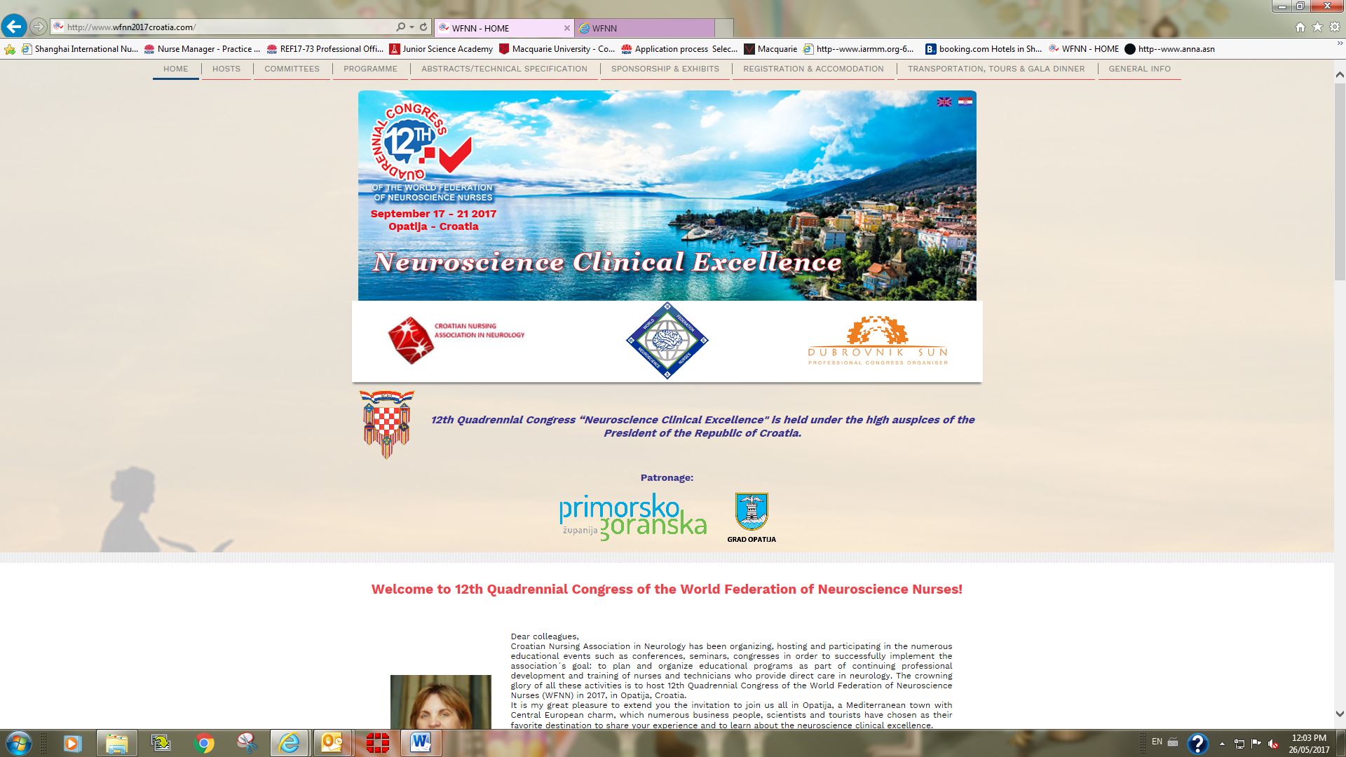

12th Quadrennial WFNN Congress

Please join us for the WFNN 12th quadrennial congress hosted by the Croatian Nursing Association in Neurology Sept 17-21, 2017 to connect with colleagues from across the world and network to improve neuroscience nursing.

For details, please check: <http://www.wfnn2017croatia.com/>

For inquiries, please contact: Vicki Evans [wfnnvicepresident@gmail.com](mailto:wfnnvicepresident@gmail.com)